Acing with Bollywood, "Jogwa" Bars high!

Beyond a few weeks, I have been writing blogs on the latest [trending Bollywood films](https://thinknsay.in/sonalimahapatra/watching-shakuntala-devi/) [and television series](http://thinknsay.in/sonalimahapatra/breathe-c-16the-four-strings-of-revelation-why-it-matters/). Undoubtedly, they all are affirmative and time worth. I used to be in a non-stop waft in making up [numerous blogs on movies, people](https://thinknsay.in/sonalimahapatra/sushant-singh-rajput-a-man-of-reality/). A quick scratch soon made me realize what I was missing on my blogs! What was the Scratch?

**What's the Scratch?**

Yes, A Scratch on my Thoughts! Recently, I watched a 2009 Marathi movie “**Jogwa**” and that I should inform you I was left dumbstruck. The reason for the scratch was my differentiative view between the Bollywood and the alternative Indian local film industries. I won't say I'm not used to vintage films, but it would be either Bollywood or Ollywood films (Odia film Industry). For the first time, I watched a Marathi film. Only I can say is it was incredible. I need to say that I experience proud nowadays to belong to a country with numerous languages and special ethnic movie industries. Such multifariousness makes me feel comfortable to watch and understand such iconic films. What else can I ask for, in movies?

Earlier than stepping into the synopsis of “**Jogwa**”, I must give you a quick short statement on how effluent Marathi movies are hidden behind the Bollywood collusion.

**Bollywood vs Marathi Film Industry**

At the same time as the theatre of Maharashtra earned recognition on the countrywide degree, the cinema didn't make a mark. A first-rate purpose was the proximity to the manufacturing centre of the Hindi cinema (Bollywood), which encroached on the identity of the Marathi cinema. Different motives include the shortage of cinema halls for distribution because of terrible marketing, loss of cash magnets, a colourful theatre scene, and the emergence of personal television. It also lacked the effective lobby on the countrywide degree unlike South Indian cinema because the nation recommended Hindi cinema for earnings particularly. Soon, the local movie industry lost its gain to Bollywood.

**We must not forget that this local Marathi Cinema gave birth to its first-ever Indian film called *"Shree Pundalik"* and *"Raja Harishchandra".* It was long back when Bollywood did even exist!**

**My Piece of Advice:**

What best to advise you is to clarify why Bollywood cannot be constantly a fantastic entertainment decision among we Indians, especially at some stage in these current years. One can decide to watch numerous antique local movies during this lockdown period which are available on various online platforms. And I can assure you won’t feel guilty of losing your precious time specifically once I advise you to watch “**Jogwa**”, a 2009 Marathi film, depicting the darkish facet of faith, its consequences, and the victory over the blind generations.

**What's behind Jogwa? Why I chose it?**

Sometimes it happens is that after watching a particular movie, you become a fan of its entire industry. Such a film is 'Jogwa' where one will positively fall in love with its every frame. It can make you curious as well as a tract of inner strength within you, at the same time. Jogwa ritual practiced throughout India, in the name of **the "Devadasi" Pratham** or custom. **Young maidens are kidnapped from several tribes forcing them to participate in the custom. For the entire life regarding them as the mistresses of the Lord or Goddesses, marrying them off to the deity, teaching them to dance and sing to entertain the deity while at midnight hours. They aren't anymore. they are mere sex slaves to the entire village.**

“Jogwa” directed by Late Rajpal Patil is based on three extraordinary Marathi novels. ‘***Chaunak*’** and ‘***Bhandar Bhog***’ by Dr. Rajan Gawas, and ‘***Darshan***’ by Charuta Sagar. “Jogwa” is a collage film that illustrates various social issues just in a single movie. These illustrations include:

1. Blind Superstitions
2. Devadasi ritual
3. Social Discrimination
4. Dalit discrimination
5. Third gender, sexual abuses, and prostitution

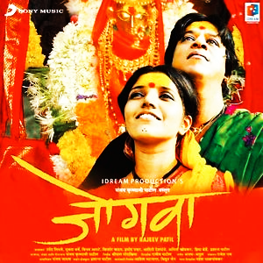

*Jogwa, a 2009 Marathi film is still considered one of the most daring contents. Starring Mukta Barve and Upendra Limaye. Directed by Late Rajeev Patil.*

**Jogwa in Short:**

The story is located in an orthodox village that shares its borders with both Maharashtra and Karnataka. In originality, the local people of these areas pray to Goddess Yellamma and Goddess Renuka. The prayers also comprise of several sacrificing rituals, Jogwa ritual, dark magic, and many other illogical blind beliefs. Though the practice is not sustained on a large scale yet the tradition is assumed to be still continuing. Karnataka government has shown a massive step towards banning of such rituals, whereas Maharashtra’s local regions are not negligible yet.

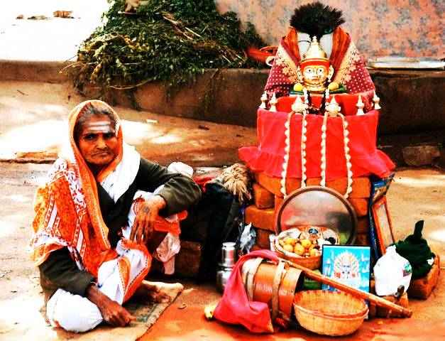

Jogwa literally means giving alms to those people. They are referred to as ***“Jogta”*** (for male), and ***“Jogtin”*** (for female). Every morning, they start their day with a regular tour to each house of the village asking for alms. They can either get money or else food, which is the only source of income for them. Basically, these people (Jogta and Jogtin) aren't beggars. They are seen as the devotees of Goddess Yellamma and Goddess Renuka. Their lives are completely surrendered to the service of these local goddesses following several superstitious believes and actions.

A Jogta (the male devotee) has to give up his manhood, control his masculine feelings, and live a life of a married woman draped in a saree throughout his life. While, a Jogtin is not allowed to love, marry, or bear children, she has to live her life as a married woman surrendered to the service of the goddesses. However, in terms of these features, a Jogtin’s life is less miserable than that of the Jogta, but no one is spared easily. A Jogta is miserably regarded as a sex object to the villagers following a quote:

***“A Jogtin is a devotee to Yellamma but a treasure to the entire village”***

**Did You Know?**

The shocking fact of the Jogwa ritual is that these so-called devotees haven’t willingly adopted such a lifestyle of living. The existing dark superstitions forced them to adopt this lifestyle for their entire life without a second thought. Through the lives of the characters, Sulli and Tayappa, the film clearly depicts and explains how these beliefs forced them to change their entire life into a cursed one.

May it be the matted hair for Sulli or passing of blood through Tayappa’s urine. Situations are as simple as it is and could be easily rectified, but orthodoxy mentalities are not less than a poison to make things complicated. There is an announcement of ‘Fatwa’- a legal declaration for their new transformation, and there is a third gender abuse too. But black old rituals try to complicate things more and generations to generations continue to accept it that way. We must understand the fact that concern the film chose to raise doesn’t point out to just a particular community, region, or country. It is a loud shout to the entire world, and India is not the only country with black ritual practices.

***“Love is a shameless plant that can grow anywhere.”***

This quote suits well to the unexpected love between Sulli and Tayappa. But it is no more a shameless de facto when this love gives them the **strength** to face the society.

**Sketch:**

The movie is for almost two hours. But what makes you experience the emotion is the most beautiful part of the movie. However, it is better not to reveal the entire suspense. I should allow you to watch it at least once in your lifetime. Every scene and dialogue is straight to the point and none of its scenes are unnecessary and useless.

 An actor or actress can achieve a victory only when they can deliver their character’s emotions straight to their audience. And while in the film called “**Jogwa**”, it is never-ending and non-stop, from one frame to the other. **‘Jiv Rangala’ song alone has won three National Awards. It is such a film that is a must to add to your watchlist whether you are a movie lover or not.**

**A Cautious Note:**

I haven’t tried to defame Bollywood movies in any way, as a movie enthusiast, it is my prior duty to always guide you with the best options regarding movies. New movies may come and go, but old movies still contain fresh fragrance, never to turn to autumn. **This blog not only contains a clean review of the Jogwa film. But also tried to explain why local and regional films are best too, apart from Hollywood and Bollywood.** To get more beautiful filmy reviews of Indian Cinema, follow me regularly here. Do like, share, and comment below to express your views on the “Jogwa” Review and help me grow.

See you next week with a brilliant surprise on another interesting factor about Indian Cinema!

﻿